Database Systems Lab
Milestone 1 — Project Submission
Smart Mini E-Commerce System
Student Name: Abdul Hameed Partner: Noman Ali Program: BSAI (B)
Milestones | Date | Version | Remarks
1. ERD Diagram | 26 April 2026 | V 1.0 | Submitted
2. Revised ERD | - | V 1.1 | Pending

1. ERD Diagram
The following Entity-Relationship Diagram shows the database structure of the Smart Mini E-Commerce System. It includes all entities, their attributes, and the relationships between them.

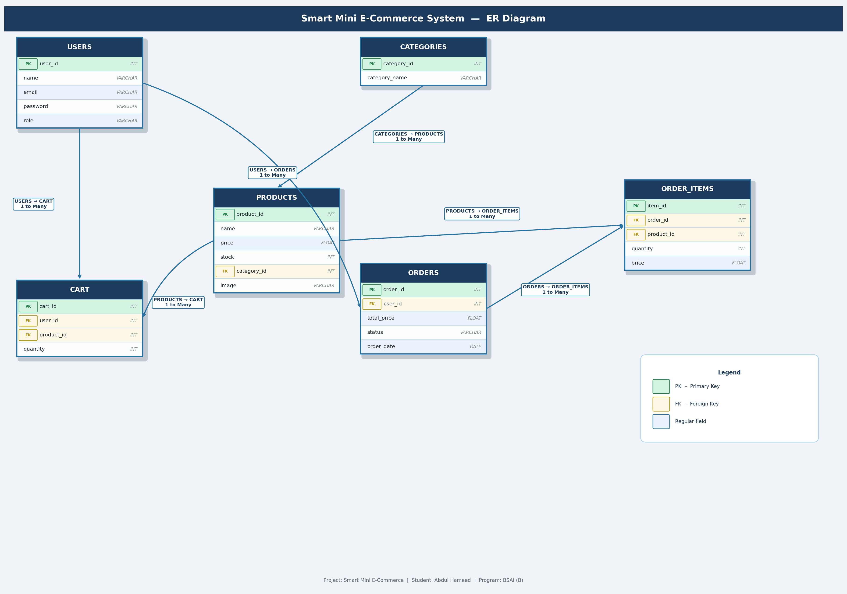

2. Relational Database Schema
The database contains the following tables with their attributes and keys:
1. users → user_id (PK), name, email, password, role, created_at
2. categories → category_id (PK), category_name
3. products → product_id (PK), name, price, stock, category_id (FK), image, created_at
4. cart → cart_id (PK), user_id (FK), product_id (FK), quantity
5. orders → order_id (PK), user_id (FK), total_price, status, order_date
6. order_items → item_id (PK), order_id (FK), product_id (FK), quantity, price

Relationships:
users → orders : One user can place many orders.
users → cart : One user can have many items in cart.
categories → products : One category can contain many products.
products → cart : One product can be added to many carts.
products → order_items : One product can appear in many order items.
orders → order_items : One order can have many order items.

